**Das EMO-Modell – practical example**

**Example 2: PRODUCTION BUDGET PLANNING**

**Budget planning**

Understanding organisations as systems means that successful organisations are able to describe and to use the interactions between all partner of interactions for satisfying the wants and needs. The main daily tasks of the managers in organisations are measuring, analysing and communicating the degree of satisfaction as well as planning actions to achieve the satisfaction (Kitzmann H. , 2007). Due to growing globalization, fast development of information and communication technologies, shortened product life-cycles, increasing the speed of changing client demands and market process, the task of planning is particularly challenging and important. Advanced budgeting approaches focusing on the rolling forecast idea supporting these challenges, and increase the importance of operational planning in organisations. Methods and models for operational planning have shown their success especially for production planning tasks, but the connection with budget planning still indicates improvement areas.

Budget planning is therefore a core task in connecting the planning of the normative, strategic and operative management. Beside the in management inside tasks, budget planning has their interconnections (input and impact) to the outside environment (partners and issues of interactions) as well to the interconnection to the organisational framework (Figure 1).

Although the budget planning is an integral part and monetary result of the operational planning in organisation, the connection of operational planning and their monetary results are mainly not sufficient elaborated and solving budget questions are mainly in the obligation of the financial departments dealing with Accounting or Controlling. The subject of the planning in the financial department focusing mainly on the financial accounting reports balance sheet, profit and loss account (P&L) and the cash-flow statement. And the target therefore is in the improving the financial figures. Different from the financial department, in the company's departments responsible for internal supply chain questions, the subject is the planning, performing and control activities of the value stream in the organisations and these internal supply chains are focusing on the logistic objectives resource utilization, order throughput time, order delivery reliability and WIP. These mostly contradicting objectives (“dilemma of operational planning”) are in the focus of different activities in production planning and control (PPC) activities. Challenges in planning are solving different conflicts, like stock level of final goods and service degree, or sales expectation and capacity utilization.

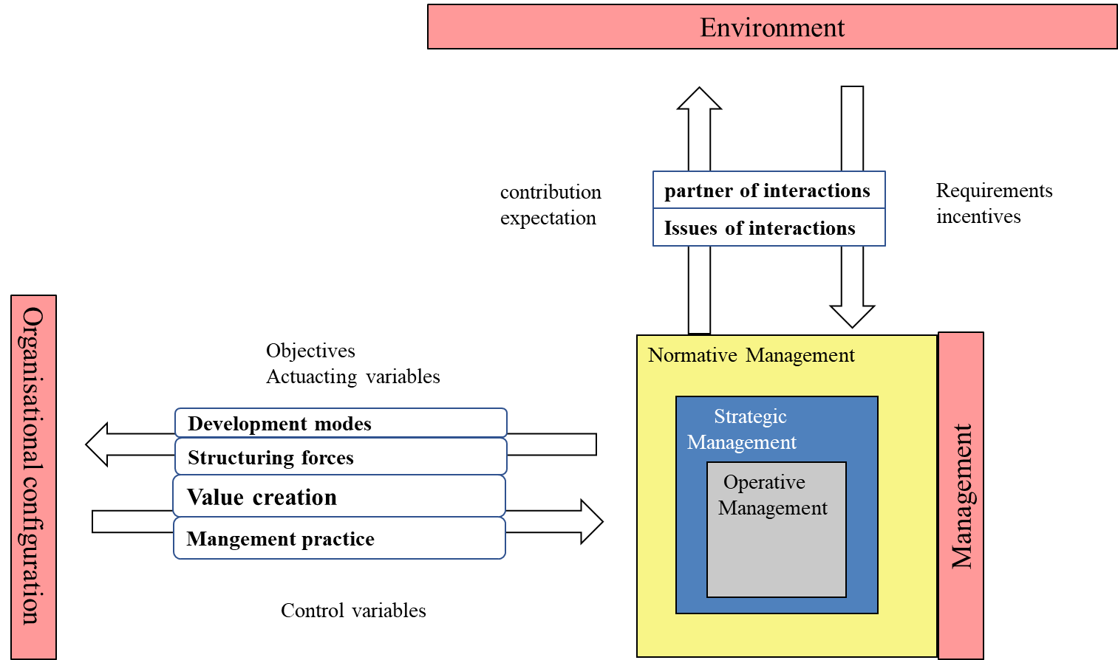

Figure 1: management task in interconnection to environment and organisation

These different targets of the activities create often conflict situations in budgeting discussion, although in general there are existing similarities in these two activities.

In the production program planning as the first main activity in PPC the main tasks are the sales planning, the inventory planning of finished goods (actually PPS-main task inventory management) and the long-term, rough resource planning (Schmidt, 2018), which are similar tasks in the budget planning process. Figure 2 gives an overview about the interconnection of the production program plan and the corresponding part in the budget plan. Operational planning in the internal supply chain is mainly done based on experiential solutions or with using of modelling approaches like simulations, queuing theory models or LOC (Nyhuis, Peter; Wiendahl, Hans-Peter, 2009). Although queuing theory models require low implematation efforts and a high illustration quality can be provided by the simulations, these types of approaches are not suitable for modelling logistic relationships, especially for the description of real production contexts (Nyhuis, P., von Cieminski, G., Fischer, A., 2005). With LOC was founded a modelling approach to overcome these limitations and reduce the complexity as well as the implementation efforts of 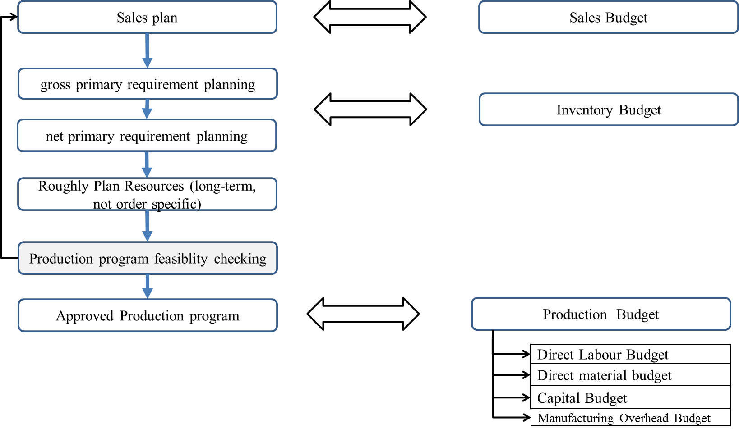the modelling.

Figure 2: production program planning and budget planning

Input parameter in regard to LOC are therefore the planned output in each period as given by the salesplan – given by the sales department - and the planned order fulfillment time of production orders, which are given by the engineers in R&D (Nyhuis, Peter; Wiendahl, Hans-Peter, 2009). Additional input parameter are of the product characteristics as technical characteristics (form, dimension, material), product engineering characteristics (mainly time aspects) and planning characteristics (quantity and volatility) (Ming-Guan Huang, M.-G. ; Chang, P.-L.; Chou, Y.-C., 2003) (Schulze, 2013). Beside these design factors the design elements and design period need to be considered, which turns the planning activities into a complex task.

According to the Funnel Model of production management by Wiendahl (Wiendahl, 1995) the main managing parameter in production are identified as time; different viewpoints of time are according the designparameter of workplaces time for the facility, for the workforce and for the workpiece (ISO, 2014) (Wiendahl, H-P; Reichardt, J; Nyhuis, P., 2015, p. 120). These three viewpoints are correspondig to the logistic targets throughput time (workpiece view), work-in-process (workpiece view) and operation utilisation (depending on the automation level connected to the workforce or equipment view). The logistic objectives are neither with non-monetary unites (WIP, throughput times) or without units (utilization and schedule reliability), but using it in financial activities of budget planning there is a need to consider also monetary figures to evaluate the efficiency material (Son, K. ;Park, C.S., 1987) and the all-over organisational results. Means, to optimize the activities in the organisation multi-target modelling is preferred to solve the task.

The calculated planned utilization of the existing capacities creates for the production management and engineers improvement areas and activities, whereas capacity adjustments, labour organisation, logistic concept, technology and product developments have impact to the organisational framework as objectives and guidelines for designing potential factors and usage of potentials and resources, and are specified in the interconnection elements development modes, structuring forces, value creation and management practise (Figure 1). These guidelines are determined in the financial area as investment, capital, labour, inventory and manufacturing overhead budgets.

**Mathematic modelling of optimizing in Production Budget planning**

**Optimazing the objectives**

Although the budgeting planning is a core task in Accounting and Controlling, take this task place at the operational management level. The goal settings of the organiation on the other hand is a task defined and designed at the normative and strategical management level. Especially in the company's departments responsible for internal supply chain questions are focusing on the logistic objectives resource utilization, order throughput time, order delivery reliability and WIP (Wiendahl H.-P. , 1997)(Figure 3)

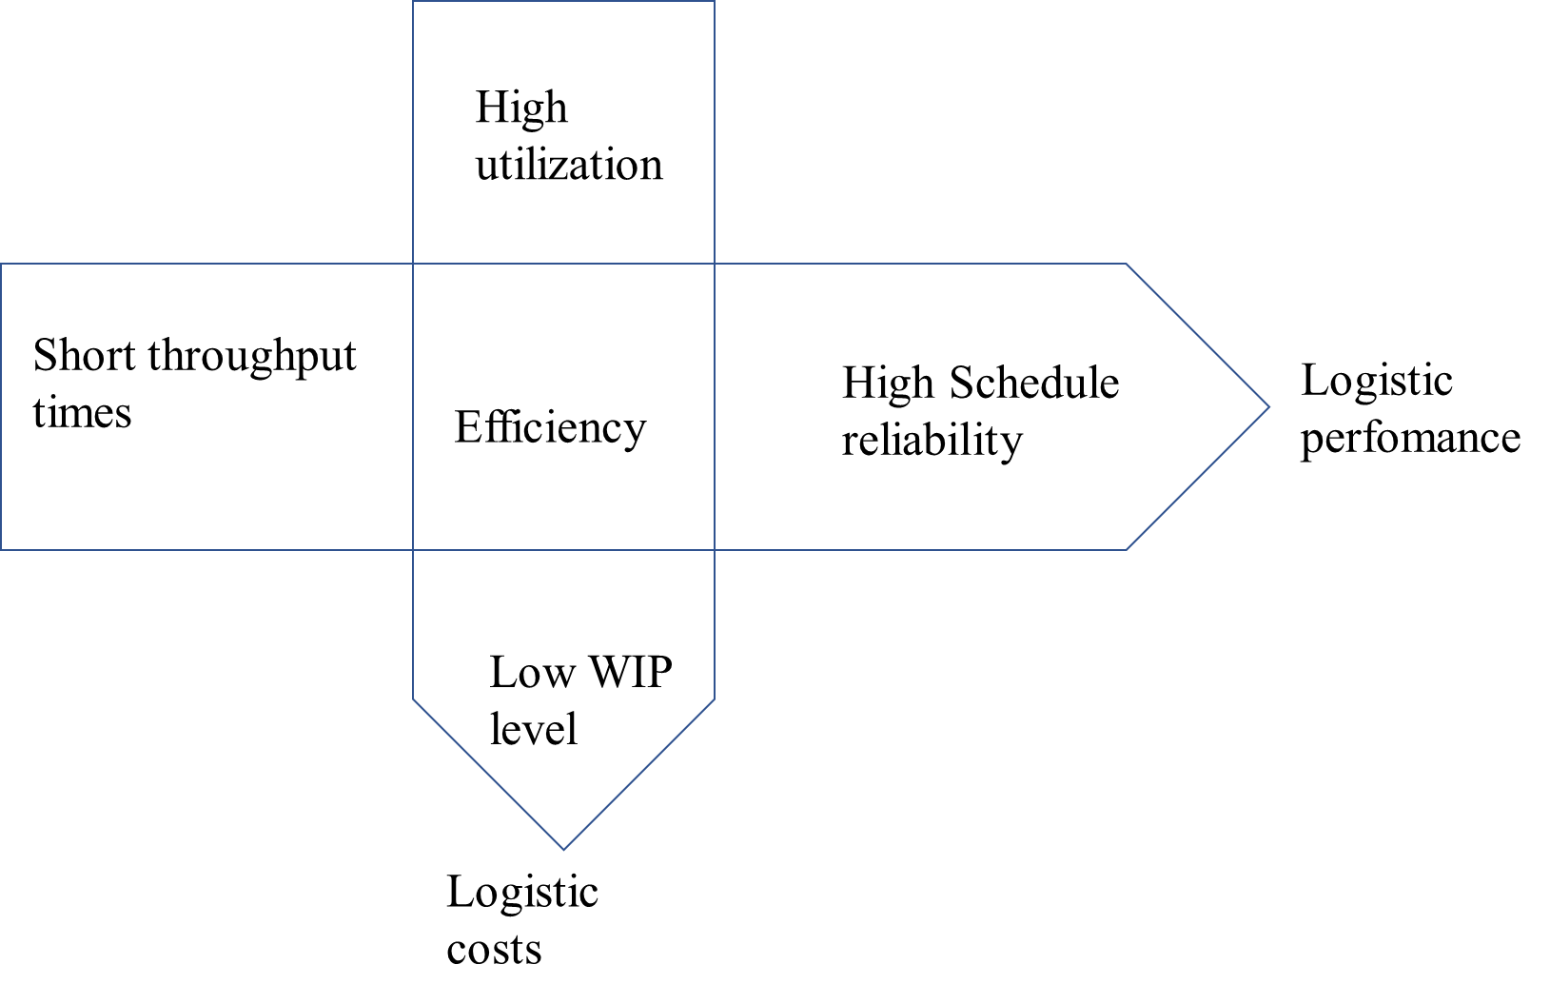

Figure 3 objectives in production logistics according (Wiendahl H.-P. , 1997)

These contradicting objectives (“dilemma of operational planning”) create challenging activities in the management to solve these objectives.

1. **Efficiency**

$$\sum_{a=1}^{A}{\sum_{t=1}^{T}{{\left({OUT(T)}_{a,t}*p_{a} - {WIP}_{m,t}*x1 + {TOP}_{a,t}*x2-c_{m,a}\right)}_{} }}→max!$$

${OUT(T)}_{a,t}*p_{a}$: Revenue of product a in period t

${WIP}_{m,t}*x1$: capital cost of WIP in period t

${TOP}_{a,t}*x2$: production cost of product a in period t

1. **Throughput time**

${TTP}_{a,t}$ $→min!$

$TTP=TIO+TOP$ Equation 1: throughput time [period]

$TOP= \frac{WC}{ROUT}$ Equation 2: operation time [period]

TTPb = tend,b - tstart,b Equation 3: throughput time of order b

WC = LS*tp + ts Equation 4: work content [hours]

LS: lotsize [units]

tp: processing time [hours]

ts: set-up time [hours]

ROUT: output rate [hours/period]

TIO = TTL + TWpost + TWpre Equation 5: inter-operation time [period]

TWpost : Post-processing waiting time [period]

TWpre : pre-processing waiting time [period]

TTL: time for transportation, storage etc. [period]

tend,b : order delivery date of order b

Post-processing and pre-processing waiting times are process depending times the workpiece is waiting for next activity (either logistic activities or next operation); example are disturbances in the logistic coordination, or unforeseen production interruptions caused by system failures.

1. **Work in process (WIP)**

${WIP}_{m,t}$ $→min!$

${WIP}_{m}= \frac{\int_{t_{0}}^{t_{1}}{OUT\left(T\right)dT- \int_{t_{0}}^{t_{1}}{IN\left(T\right)dT}}}{t_{1}- t_{0}}$ Equation 6: mean WIP [hours]

WIPm : mean WIP [hours]

IN(T) : input (cumulative work content of incoming operations as a function of time) [hours]

OUT(T) : output (cumulative work content of outgoing operations as a function of time) [hours]

t0 : beginning of the reference period

t1 : end of the reference period

$R_{m}= \frac{{WIP}_{m}}{{ROUT}_{m}}$ Equation 7: mean range of WIP [period]

WIPm : mean WIP [hours]

ROUTm : mean output rate [hours/period]

${ROUT}_{m}= \frac{\sum_{i=1}^{n}{{WC}_{i}}}{t_{1}- t_{0}}$ Equation 8: mean output rate [hours/period]

${WIP}_{rel}= \frac{{WIP}_{m}}{{WIPI}_{min}}$ Equation 9: relative WIP

${WIPI}_{min}= {WC}_{m}*\left(1+{WC}_{v}^{2}\right)+ {TTL}_{m}$ Equation 10: ideal minimum WIP

${WC}_{v}= \frac{{WC}_{s}}{{WC}_{m}}$ Equation 11: coefficient of variation for the work content [-]

${WC}_{s}= \sqrt{\frac{\sum_{i=1}^{n}{{\left({WC}_{m}- {WC}_{i}\right)}^{2}}}{n}}$ Equation 12; standard deviation of the work content [hrs]

1. **Utilization**

**Um → max!, with Um [0 … 1]**

$U_{m}= \frac{{ROUT}_{m}}{{ROUT}_{max}}$ Equation 13: mean Utilization [-]

ROUTm: mean output rate [hours/period]

ROUTmax: maximum output rate [hours/period]

CAP = w * CAPw  [hours / period]

w: number of workstation; m ∈ ℕ

CAPw : capacy per period [hours/period]

1. **Schedule reliability – not relevant in the 1st view**

**Input parameter**

The input parameter of the system consist of different parameter determined and predefined as results of difffent managerial task.

**Input**

|  |  |  |  |  |
| --- | --- | --- | --- | --- |
| **parameter** | | **Type of**  **changeability** | **Level of**  **management** | **Responsible** |
| Ordera (Pa,Qa,b,tend,b,pa): orders of product a during reference period: | Pa : product a  Defined quality characteristics | Cube-Fix | operative | Product development |
| Adjustable | strategic | Product development |
| Qa,b : order quantity of product a in order b   * WCb (work content) | Cube-fix | operative | Sales / marketing plan |
| adjustable | Operative | Sales / marketing plan |
| tend : order delivery date of order b | Cube-fix | Operative | Sales / marketing plan |
| adjustable | Operative | Sales / marketing plan |
| pa : price of product a : | Cube-fix | Operative | Sales / marketing plan |
| adjustable | Operative | Sales / marketing plan |
| cm,a : material cost per product fix/adjustable | | Cube-fix | Operative | Product development |
| adjustable | operative | Product development |
| tp,a: operation time per product : fix/adjustable | | Cube-fix | operative | Product development |
| adjustable |  | Product development |
| ts,a set-up time per product : fix/adjustable | | Cube-fix | operative | Process development |
| adjustable |  | Process development |
| TIOa: inter-operation time per product: fix/adjustable | | Cube-fix | operative | Process development |
| adjustable |  | Process development |
| w: number of workstation; w ∈ ℕ; adjustable | | Cube-fix | operative | Process development |
| adjustable |  | Process development |
| CAPw,x : capacy of workstation w per period x; adjustable | | Cube-fix | operative | Process development |
| adjustable |  | Process development |
| t: period months, year,…….. | |  |  |  |

Cube-fix: fix, with consideration of limits in the frame of flexibility parameter

1. **budget planning in practice**

Case company is young start-up company and producing electric scooter to service the customers with trnsport for short distances. The business was established 5 years ago and the budget plan for 2020 was done in several steps. Figure 4 shows the result of the LOC planning based on sales plans. The company is producing 2 types of e-scooter and the sales plan was done on weekly bases. The troughput diagram shows that the sales of the products is better than expected and growing during the year, and the company is able to sale more than they are able to produce with tendency of overloading the production; adjustment in the capacity was considered. The utilization rate of the equipment during the year shows with 73,5 % or 202,95 h per week possibilities to increase the usage of the production units, which shows the location of the operation point in the output diagram. The difference of the maximum output rate and average output rate shows a WIP independent loss of 72,78h per week, and request adjustments in the capacity structure. Work content distribution shows, that the demand during the year is not homogenous with a range between 633 and 945,5 h per week.

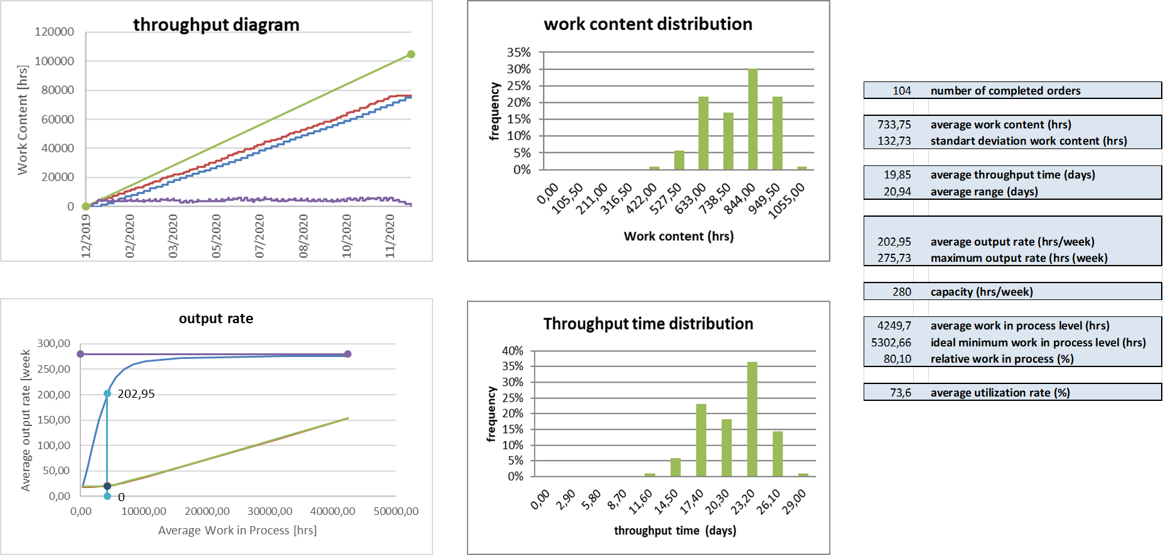The volatile sales demand is in conflict with the engineering ideal of a balanced production and request to revise sales demand distribution as well as production and logistics concepts, which has also impact on the throughput time distribution. Based on the results of the planning with LOC the company initiated different activities, impact on the investement budget, the sales budget, the direct labour, direct capital and inventory budgets.

Figure 4: LOC results of case company budget planning

Table 1: Outcome of production budget planning activities

|  |  |  |  |
| --- | --- | --- | --- |
| **initial** | **improved** |  | **remarks** |
| 104 | 104 | **number of completed orders** |  |
| 733,75 | 733,75 | **average work content (hrs)** |  |
| 132,73 | 132,73 | **standard deviation work content (hrs)** |  |
| 19,85 | 18,85 | **average throughput time (days)** | **Reduced 1 day** |
| 20,94 | 19,54 | **average range (days)** |  |
| 202,95 | 199,76 | **average output rate (hrs/week)** |  |
| 275,73 | 236,95 | **maximum output rate (hrs (week)** |  |
| 280 | 240 | **capacity (hrs/week)** | **Reduced 40h/week** |
| 4249,7 | 3902,87 | **average work in process level (hrs)** | **Reduced 350h** |
| 5302,66 | 3787,62 | **ideal minimum work in process level (hrs)** |  |
| 80,10 | 103 | **Relative work in process (%)** |  |
| 73,6 | 84,3 | **average utilization rate (%)** | **Increased** |

The production speed were increased (organisational changes) and the capacity reduced by 40 hrs/week (investment budget), which had the effect of increasing utilization (direct capacity budget) and decreasing the WIP level (inventory budget) without significant changing of the average output rate (Table 1).

# References

ISO. (2014). *ISO 22400-2: Automation systems and integration — Key performance indicators for manufacturing operations management. Part 2: Definitions and descriptions.*

Kitzmann, H. (2007). Limitation of Measuring and Managing success. *Scienta Nova*, 13-24.

Ming-Guan Huang, M.-G. ; Chang, P.-L.; Chou, Y.-C. (2003). Fast algorithm for evaluating the similarity of manufacturing processes within a dynamic production environment. *International Journal of Production Research*, 4171-4183.

Nyhuis, P., von Cieminski, G., Fischer, A. (2005). Applying Simulation and Analytical Models for Logistic Performance Prediction. *Annals of the CIRP, 54*(1), 417-422.

Nyhuis, Peter; Wiendahl, Hans-Peter. (2009). *Fundamentals of Production Logistics.* (R. Rossi, Trans.) Berlin, Heidelberg: Springer Verlag.

Schmidt, M. (2018). *Beeinflussung logistischer Zielgrößen in der unternehmensinternen Lieferkette durch die Produktionsplanung und -steuerung und das Produktionscontrolling.* Garbsen: PZH Verlag.

Schulze, C. P. (2013). *Planung und Bewertung von Fabrikstrukturen.* Hannover: PZH Verlag.

Son, K. ;Park, C.S. (1987). Economic Measure of Productivity, Quality and Flexibility in Advanced manufacturing Systems. *Journal of Manufacturing Systems*, 193-207.

Wiendahl, H.-P. (1995). *Load-Oriented Manufacturing Control.* Berlin: Springer-Verlag.

Wiendahl, H.-P. (1997). *Fertigungsregelung: Logistische Beherrschung von Fertigungsabläufen auf Basis des Trichtermodells.* München: Carl Hanser.

Wiendahl, H-P; Reichardt, J; Nyhuis, P. (2015). *Handbook Factory Planning and Design.* Berlin Heidelberg: Springer-Verlag.